ABSTRACT

The Devanagari Character Recognition System is designed to perform Optical Character Recognition (OCR) on Devanagari characters, supporting a wide range of Nepali alphabets. The system architecture comprises five main stages: preprocessing, segmentation, feature extraction, prediction, and postprocessing. The solution leverages a Convolutional Neural Network (CNN) for model training and image processing techniques for accurate character recognition. The backend is developed using Flask, providing API and business logic functionalities, while the frontend is implemented in React for an interactive user experience. PostgreSQL serves as the database for secure user authentication, image storage, and maintaining a prediction history for future reference.
The system allows users to upload images for recognition without quality loss and includes an audio generation feature for recognized characters. Images are also stored for future model training to improve accuracy. Extensive testing of different algorithms revealed varying levels of accuracy, emphasizing the system’s adaptability. The project demonstrates a collaborative effort integrating software and hardware components, offering a robust solution for recognizing Devanagari characters.

Keywords: Devanagari character recognition, Convolutional Neural Network, image processing, optical character recognition, user authentication, image segmentation.

Table of Contents
ABSTRACT i
List of Figures v
List of Abbreviations vi
Chapter 1: Introduction 1
1.1 Introduction 1
1.1.1 Devanagari Characters 1
1.1.2 Optical Character Recognition 1
1.1.3 Machine Learning 1
1.1.4 Deep Learning 2
1.1.5 Convolutional Neural Networks (CNN) 2
1.2 Problem Definition 3
1.3 Objectives 3
1.4 Scope and Limitation 3
1.7 Report Organization 4
Chapter 2: Literature Review 5
2.1 Review of Papers 5
2.1.1 Offline Handwritten Numerals Recognition using Correlation 5
2.1.2 Devanagari Character Recognition Using Neural Networks 5
2.1.3 Handwritten Devanagari Character Recognition using Neural Network 6
2.1.4 Advancements in Handwritten Devanagari Character Recognition 6
2.1.5 Deep Learning Based Real Time Devanagari Character Recognition 6
Chapter 3: System Analysis 7
3.1 Requirement Analysis 7
3.1.1 Functional Requirements 7
3.1.2 Non-Functional Requirements 8
3.2 Feasibility Analysis 9
3.2.1 Economic Feasibility 9
3.2.2 Operational Feasibility 9
3.2.3 Technical Feasibility 9
3.2.4 Schedule Feasibility 10
3.3 Constructing System Requirements 10
Chapter 4: System Design and Implementation 12
4.1 System Design 12
4.1.1 Block Diagram 12
4.1.2 Dataset Preparation 13
4.1.3 Database Design: 13
4.2 Implementation 14
4.2.1 Implementation in Python 14
4.3 Neural Network Design and Implementation 15
4.3.1 Convolutional Neural Network 15
4.4 Image Processing Model 16
4.4.1 Image Acquisition 16
4.4.2 Image Preprocessing 17
4.4.4 Character Prediction/classification 18
4.4.5 Character Localization 18
4.4.6 Character Recognition 18
4.5 Sequence Flow Diagram 20
4.6 List of Algorithms 21
4.6.1 Load Dataset 21
4.6.2 Create CNN Model 21
4.6.3 Train CNN Model 21
4.6.4 Image Processing 22
4.6.5 Character Recognition & Prediction 22
4.7 Usage of Algorithms in Our Project 22
Chapter 5: System Testing 24
5.1 Unit Testing 24
5.2 Integration Testing 28
5.3 System Testing 32
Chapter 6: Maintenance and Support 35
6.1 Maintenance 35
6.2 Support 35
Chapter 7: Conclusion & Future enhancements 36
7.1 Conclusion 36
7.2 Future enhancements 36
REFERENCES 37
APPENDIX 38
Appendix A: Screenshots 38
Appendix B: Source Code 40
i. Model Training 40
ii. Image Processing 41

List of Figures
Figure 1. 1: CNN 3
Figure 3. 1: Use Case Diagram of DCR 9
Figure 3. 2: Gantt Chart 12
Figure 3. 3: DFD 13
Figure 4. 1: Block Diagram of DCR system 14
Figure 4. 2: ER Diagram 16
Figure 4. 3: CNN Architecture 18
Figure 4. 4: Character Creation using paint 19
Figure: Login screen 38
Figure: Image Upload Section 38
Figure: Model Prediction Result 39

List of Abbreviations
DCR | Devanagari Character Recognition
NN | Neural Network
CNN | Convolutional Neural Network
DFD | Data Flow Diagram
ERD | Entity Relationship Diagram
FFNN | Feed Forward Neural Network
RELU | Rectified Linear Unit
ML | Machine Learning
DL | Deep Learning
AI | Artificial Intelligence
OCR | Optical Character Recognition
IDLE | Integrated Development Environment
CSV | Comma Separated Value

Chapter 1: Introduction

1.1 Introduction

1.1.1 Devanagari Characters
The Devanagari script, which is Nepal's national font and is widely used across India, encompasses a comprehensive character set including 10 numerals, 36 consonants, and 13 vowels. The subtle structural similarities between certain characters make this script particularly interesting from a recognition perspective. For instance, distinguishing between 'ब' and 'व' requires identifying a minute difference in the internal cross mark, while 'ङ' and 'ड' are differentiated solely by the presence of a dot. Similar structural patterns are observed between characters like 'प', 'म', and 'य', as well as between the numeral '२' and the consonant 'र'. The script also features compound characters such as 'क्ष', 'त्र', and 'ज्ञ', which are formed by combining basic consonants, adding another layer of complexity to character recognition. These intricate similarities and compound formations present unique challenges in developing accurate recognition systems, requiring sophisticated image processing and pattern recognition techniques to achieve reliable character identification^{[1]}.

1.1.2 Optical Character Recognition
Through the years, character recognition technology has advanced dramatically and become an essential tool for a wide range of applications. Optical Character identification (OCR) systems are used in many aspects of modern computing, from aiding robotic vision systems to translating documents to digital text and facilitating automatic number plate identification. These recognition systems fall into two primary categories: offline character recognition, which uses previously typed or printed text, and online character recognition, which processes characters as they are written in real time^{[2]}. Since it may operate independently after the OCR model has been trained, the latter has become especially well-known for its adaptability and broader applicability. Machine learning technology, which is at the heart of these systems, allows computers to learn and increase the accuracy of their recognition through pattern analysis and deep learning algorithms, boosting their dependability for real-world applications in both business and daily life.

1.1.3 Machine Learning
A basic component of artificial intelligence, machine learning (ML) lets systems learn from data by pattern recognition instead of conventional programming techniques. Under our Devanagari Character Recognition research, the algorithm learns to recognise characters by analysing several handwritten samples under varying writing styles. ML is especially helpful for jobs with slight variations, including spotting identical Devanagari letters, since its actual power resides in its ability to improve performance over time.
Supervised learning, in which a model is trained using both known outcomes and input data therefore allowing it to provide predictions based on labelled instances, is a fundamental idea in machine learning. Unsupervised learning, on the other hand, lets the model find hidden structures like clusters or groups by allowing it to spot trends in data without specified labels. Optimization plays a vital part in ML, as it includes altering model parameters to minimize the loss function and enhance accuracy. With lower values suggesting better outcomes, loss functions as Mean Squared Error or Categorical Cross Entropy help evaluate model effectiveness. But if the model memorizes the training set rather than generalizing patterns or learns insufficient from the input, underfitting and overfitting might result. Changing training data, loss functions, and model parameters helps to lessen these problems.

1.1.4 Deep Learning
Deep learning represents an advanced subset of machine learning within artificial intelligence, differentiated by its capacity to interpret and learn from unstructured and unlabeled data without human supervision. At its base are neural networks that imitate the human brain's structure and function, with Convolutional Neural Networks (CNNs) playing a particularly vital role in image-processing tasks. In our Devanagari Character Recognition system, deep learning enables the model to automatically detect detailed patterns in character images using numerous layers of neural networks. These networks progressively learn information from simple edges and curves to complicated character shapes, making them exceptionally good at managing the intricate distinctions in Devanagari characters.

1.1.5 Convolutional Neural Networks (CNN)
Convolutional Neural Networks (CNNs) are a class of deep learning models frequently utilized for tasks such as image classification, similarity-based clustering (like image search), and object recognition. These algorithms excel in identifying different aspects in visual data, from faces and people to street signs and even specific species, such as platypuses. CNNs are also successful in optical character recognition (OCR), which translates printed or handwritten text into digital form, enabling natural language processing and study of physical documents. Recently, CNNs have been adapted for audio analysis by encoding sound as spectrograms, and academics are exploring their usage in text analysis and graph data with techniques like graph convolutional networks.
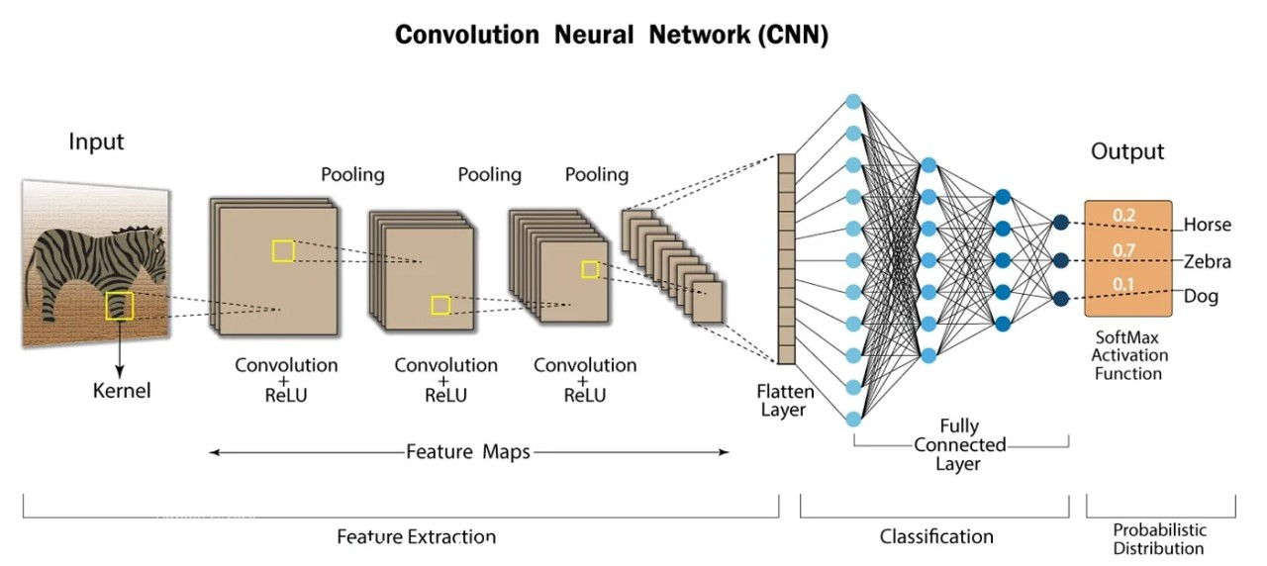
Figure 1. 1: CNN

The extensive use of CNNs in image identification has generated substantial developments in computer vision (CV), leading to breakthroughs in domains including autonomous vehicles, robotics, drones, security systems, medical diagnostics, and even aiding individuals with vision impairments. CNNs consist of many critical layers: the convolutional layer, where convolution operations occur, applying filters to the input image and performing element-wise multiplication and summing. A pooling layer, frequently Max-Pooling, follows to minimize the input size by selecting the maximum value in a particular window, thus down sampling the data. Dropout is another essential approach that helps minimize overfitting by randomly deactivating neurons during training, requiring the model to acquire more broad features. The Flatten layer turns multi-dimensional input into a 1D vector, while the Dense layer is utilized for classification following the convolutional operations. Each of these layers serves a critical role in enabling CNNs to handle complicated visual data successfully.

1.2 Problem Definition
Character recognition systems, while advanced for English and numerical scripts, face unique hurdles when processing Devanagari text. The complexity of Devanagari writing, with its similar-looking characters (like 'ब' and 'व'), compound characters (like 'क्ष', 'त्र', 'ज्ञ'), and intricate formation rules, makes accurate recognition difficult. This limitation affects different uses, from document digitization to number plate scanning. Our project aims to address these challenges by creating an efficient Devanagari Character Recognition system using modern machine learning techniques to improve accuracy in character identification.

1.3 Objectives
The primary objective of this system is to conduct extensive research on Devanagari character recognition in the field of Computer Vision. The system leverages a Convolutional Neural Network (CNN) model to provide reliable predictions for Devanagari characters. The system aims to offer a user-friendly and efficient solution for character recognition by utilizing simple image processing techniques.
Key objective include:
- Recognize and predict Devanagari characters from user-uploaded images stored locally, ensuring high accuracy with minimal quality loss.

1.4 Scope and Limitation
This project focuses on applying Deep Learning techniques, specifically through a Flask and React-based web application, for Devanagari character identification. The system combines image processing with OpenCV and Convolutional Neural Networks (CNN) to analyze and predict characters from uploaded photos. It also provides user management tools, ensuring that each user’s data is safely saved and handled.
The scope of the project comprises identifying 36 characters using CNN, coupled with a Flask backend to handle API calls and a React frontend for a seamless user interface experience. It features JWT authentication for secure user access and SQLAlchemy for data persistence, with PostgreSQL utilized as the database for user administration. However, the system has certain drawbacks, such as identifying just one character at a time, browser-based processing with limited memory capacity, and speed strongly depending on the quality and segmentation of the input images. Additionally, the user interface is constrained to the web browser environment. The technical stack combines Flask, OpenCV, SQLAlchemy, and JWT for the backend, with React, Vite, and Tailwind CSS for the frontend, enabling efficient and current web development methods. The architecture of the system follows standard software development principles, with adequately defined APIs and robust error-handling mechanisms to offer accurate character recognition while assuring user data confidentiality and effective session management.

1.7 Report Organization
In Chapter 1, this report introduces why the system is built and how. It also explains the objectives and features of the project in detail, along with the scope and limitations of the system.
In Chapter 2, this report discusses the existing systems related to Devanagari Character Recognition and reviews previous research and methodologies.
In Chapter 3, this report discusses the requirement analysis and feasibility study of the system. The process modeling techniques are used to provide insights into system requirements.
In Chapter 4, this report discusses the system design and implementation. It also covers the Neural Network Design, including dataset preparation, preprocessing, feature extraction, and Convolutional Neural Network (CNN) implementation.
In Chapter 5, this report discusses the tools used in this project to make it functional. The system testing process is explained in detail, including unit testing, integration testing, and system testing with structured input and output validation.
In Chapter 6, this report discusses the maintenance and support strategies implemented for the system, ensuring its long-term usability and performance improvements.
In Chapter 7, this report discusses the conclusion and potential future enhancements of the project, such as mobile application integration, real-time recognition, and advanced model optimizations.

Chapter 2: Literature Review
The objective of this system is to conduct research and deploy Devanagari character recognition utilizing a modern web-based architecture. While prior solutions largely focus on standalone applications, this project combines detailed research with practical implementation in a full-stack Flask-React approach, enabling real-time processing capabilities. The system not only investigates the obstacles in recognizing Devanagari characters but also handles these concerns by incorporating OpenCV preprocessing and CNN models into a production-grade web framework, enabling character recognition through secure APIs and database persistence.
This project attempts to provide a deeper understanding of Devanagari character recognition by merging AI technology with modern web frameworks. Through both theoretical study and practical implementation, the system processes submitted photos using a secure pipeline, integrating JWT authentication and PostgreSQL data management for optimal user interaction and prediction history storage. The research aims to improve the accuracy and efficiency of Devanagari character recognition, while the implementation demonstrates the practical application of these advancements in a scalable web architecture.
The system achieves accurate character prediction with the integration of a 36-class CNN model, reinforced by confidence rating and aural feedback elements. In addition to detecting characters, the system focuses user experience by including responsive design and easy interfaces. This research-driven approach, accompanying the creation of a production-ready solution, provides as a helpful reference for the development of AI-powered apps in contemporary web frameworks, notably for Devanagari script recognition jobs.

2.1 Review of Papers

2.1.1 Offline Handwritten Numerals Recognition using Correlation
In this paper, the author proposed a system designed to efficiently recognize offline handwritten digits with higher accuracy than previous methods. Previous handwritten number recognition systems were limited to recognizing only single digits, and they lacked the capability to recognize multiple numbers simultaneously. The author addressed this limitation by focusing on improving the segmentation process, which efficiently isolates individual digits. This enhancement allowed the system to perform better in terms of both accuracy and functionality for recognizing handwritten numerals^{[8]}.

2.1.2 Devanagari Character Recognition Using Neural Networks
In this paper, a neural network-based approach is proposed for building an automatic offline character recognition system for Devanagari. Devanagari is an Indo-Aryan script used predominantly in languages like Hindi and Marathi, with about 71 million speakers. While there has been considerable work done on character recognition for other Indian languages such as Hindi, Tamil, and Bengali, Devanagari has not seen much research, especially in character recognition. This paper addresses that gap by using a multilayer perceptron with a hidden layer for Devanagari character recognition. The characters are represented as patterns in a binary matrix format (n*n) and stored in a file. A backpropagation neural network is employed for efficient recognition, and the rectified neuron values are transmitted through the feed-forward method in the neural network^{[9]}.

2.1.3 Handwritten Devanagari Character Recognition using Neural Network
In this digital era, organizations that store information in handwritten documents can utilize handwritten character recognition (HCR) to convert this information into digital form. Recognizing handwritten Devanagari characters presents challenges due to the presence of header lines, conjunct characters, and the similarity in shapes of multiple characters. This paper presents a grid-based method that combines image centroid zone and zone centroid zone techniques to recognize individual characters or numerical images. In the feature extraction process, the image is divided into n equal-sized grids or zones. The average distance of all pixels from the image centroid or the grid centroid is computed. The method combines the image centroid and zone centroid approaches to compute the average distance of all pixels in each grid with respect to both centroids, generating a feature vector of size 2xn. This feature vector is then used as input to a feed-forward neural network for character recognition^{[2]}. The entire recognition process involves stages such as document preprocessing, segmentation, feature extraction using the grid-based approach, and recognition through a feed-forward neural network.

2.1.4 Advancements in Handwritten Devanagari Character Recognition
This study presents a significant breakthrough in identifying handwritten Devanagari characters by implementing transfer learning and leveraging the VGG16 convolutional neural network architecture. The study centers on the challenges linked to traditional methods of identifying the Devanagari script. Many of India extensively utilize Devanagari to write languages such as Hindi, Marathi, and Sanskrit. By employing transfer learning, one can leverage the strengths of pre-trained models to improve accuracy and efficiency, especially when dealing with small training datasets. The results indicate a recognition accuracy of 96.58%, representing a substantial improvement compared to recent studies that achieved 82.12% accuracy using slice-based character classification methods and 90% accuracy using a hybrid approach combining CNNs with traditional image preprocessing techniques. The research has made a valuable contribution by creating a unique dataset of 92,000 pictures of handwritten Devanagari characters. This dataset will serve as a valuable resource for future investigations. The optimization of the VGG16 model for this dataset showcases the ability of transfer learning to improve the recognition of complex scripts ^{[9]}.

2.1.5 Deep Learning Based Real Time Devanagari Character Recognition
This paper discusses the development of a real-time Devanagari character recognition system using deep learning techniques. The system is designed to recognize characters in real-time, making it suitable for applications such as automated data entry, document processing, and educational tools. The paper explores the use of convolutional neural networks (CNNs) and transfer learning to achieve high accuracy and efficiency. The results demonstrate a recognition accuracy of 96.02%, which is a significant improvement over previous methods. The paper also highlights the importance of creating large, diverse datasets for training and testing such systems ^{[9]}.

Chapter 3: System Analysis

3.1 Requirement Analysis
The requirement includes both functional and non- functional requirements:

3.1.1 Functional Requirements
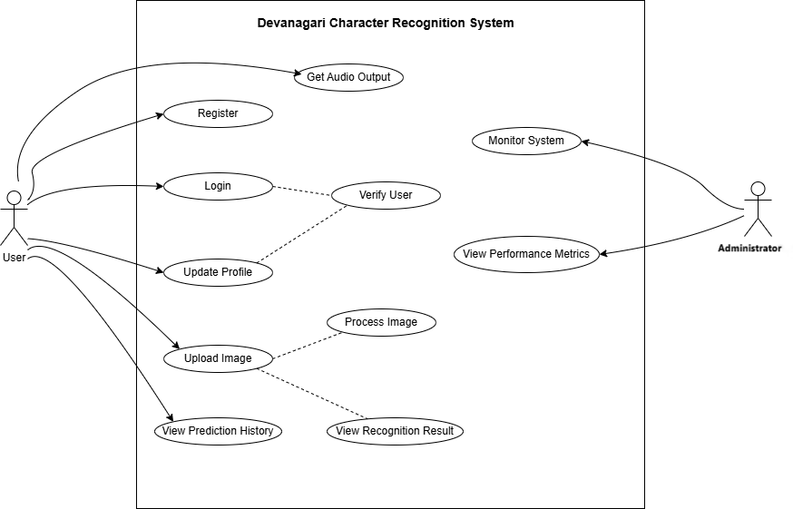
Functional requirements define the specific tasks or operations that the system, or its components, must be capable of performing. These requirements can be effectively illustrated using Use Case Diagrams, which serve as a powerful tool for visualizing the system's functionality. Use Case Diagrams not only help translate functional requirements into design decisions and development priorities but also assist in identifying internal or external factors that may impact the system and should be considered during implementation. They provide a high-level overview of the system from an external perspective, focusing on how the system interacts with users (actors) without delving into the technical intricacies of how these functionalities are implemented. This approach ensures clarity in understanding the system's behavior and guides the development process effectively.

Figure 3.1: Use case diagram of DCR
The Use Case Diagram of DCR consisted of the two actors i.e., user and Administrator. The actors interact with the DCR system shown in the middle rectangle. The use cases are represented in an oval shape. They include and extend links are used to show the relation between the use cases.
The Devanagari Handwritten characters should be drawn by the user. The character dawn is given to the DCR system directly using the file name where the image is saved or using the camera. The DCR system should have the functionality to scan the image given by the user. The scanning process includes pre-processing and segmentation functions serially. The DCR system should also consist the functionality to check the pixels using neural network for the purpose of recognizing the characters. The system then finally has the functionality to display the character recognized using the user interface.
The above-described functional requirements are mandatory for developing a well-functioning DCR system.

3.1.2 Non-Functional Requirements
The non-functional requirements are:
Performance
The DCR system must deliver accurate character recognition while maintaining efficient resource utilization. This includes optimizing memory, CPU, and storage usage to ensure smooth operation even under varying workloads. The system should minimize latency during character recognition and processing to provide a seamless user experience.
Scalability
The system must be designed to handle an increasing volume of characters as demand grows. Whether processing a single character or multiple characters simultaneously, the DCR system should scale efficiently without compromising performance or accuracy. This ensures the system remains robust and adaptable to future needs.
Reliability
Reliability is critical for the DCR system, as it must consistently classify individual characters with high accuracy. To achieve this, the system employs Convolutional Neural Networks (CNNs), which are specifically trained to recognize Devanagari characters. The use of CNNs ensures reliable predictions and minimizes errors in character classification.
Recoverability
In the event of incorrect predictions, the system should provide users with actionable feedback or alternative solutions. For example, it could suggest possible corrections or allow users to re-upload images for improved results. This recoverability feature enhances user trust and improves the overall usability of the system.
Usability
The DCR system is designed to be accessible to users familiar with Python and machine learning environments. It provides a user-friendly interface for uploading images and viewing recognition results, while also offering flexibility for advanced users to customize or extend the system. Clear documentation and intuitive workflows further enhance usability.
Interoperability

The system integrates various machine learning frameworks and libraries within a Python-based environment. These components must operate seamlessly together to ensure compatibility and consistent performance. By adhering to industry standards and leveraging widely used tools, the DCR system achieves high interoperability, making it easier to maintain and extend.

3.2 Feasibility Analysis
The feasibility analysis assesses the viability and quality of a project, providing essential information to aid decision-making. A comprehensive feasibility study has been conducted to determine the potential success of the Devanagari Character Recognition (DCR) system. The following aspects of the feasibility analysis have been considered in evaluating the project's feasibility:

3.2.1 Economic Feasibility
The project is economically viable as it works on free, open-source tools like Python, Anaconda, and TensorFlow. Model training was performed on a local machine with 8GB RAM, which, while limited, proved sufficient for development. This eliminates the need for expensive hardware or cloud computing, making the job cost-effective.

3.2.2 Operational Feasibility
The Devanagari Character Recognition (DCR) system is designed to be operationally practical and user-friendly. It leverages a Convolutional Neural Network (CNN) to recognize Devanagari characters with a high degree of accuracy, while also accounting for a manageable error margin. The system is implemented as a Python-based program with a simple and intuitive user interface, ensuring ease of use for general users.
The demand for such a system is evident, particularly in regions like Nepal, where there is limited research and development in the field of Natural Language Processing (NLP) for Devanagari script. By addressing this gap, the DCR system fulfills a clear need, enhancing its operational relevance and usability. Users only need to install Python and the necessary dependencies to run the system, making it accessible even to those with basic technical knowledge.

3.2.3 Technical Feasibility
The technical feasibility of the Devanagari Character Recognition (DCR) system is ensured through the use of robust and widely-adopted technologies. The system is developed using Python , along with machine learning frameworks such as Keras and TensorFlow , which are well-suited for implementing CNN-based models.

The development team possesses strong technical expertise in machine learning algorithms, image processing, and neural network design, enabling the successful implementation of the system. Model training was conducted on a local machine with an Intel Core i5 10th Generation processor and, demonstrating that the system can be developed and tested effectively without requiring specialized hardware. This confirms the technical feasibility of the project and ensures that the system can be deployed and maintained with existing resources.

3.2.4 Schedule Feasibility
The Gantt chart for the Devanagari Character Recognition (DCR) project is as follows: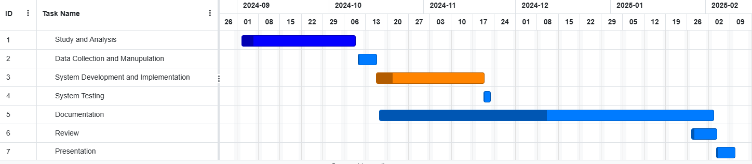
Figure 3. 2: Gantt Chart

The DCR system schedule consists of seven major activities. The Study and Analysis phase is planned to be completed within the first month. Data Collection and Manipulation is scheduled for the following 10 days. The Development and Implementation phase will begin in the third phase and is planned to run for one month. System Testing is scheduled to take place over the next 7 days. Documentation will begin after system development starts and is planned to be completed within 50 days. The System Review phase is scheduled for 10 days in the sixth phase. Finally, the Presentation will be conducted in the last phase, lasting for 5 days.

3.3 Constructing System Requirements
- Process Modeling
Process modeling shows how data is acquired, processed, stored, and exchanged inside a system. The Data Flow Diagram (DFD) is a standard tool for this, representing data transfer between entities, processes, and data repositories. The Devanagari Character Recognition (DCR) system’s DFD contains three layers, each offering a more complete breakdown of the data flow. As the tiers progress, the graphic reveals greater specific insights into the system’s activities.
- Level 0 DFD:
The Level 0 DFD is the simplest representation of the data flow within the system, providing a basic overview of the flow of data. It shows that the input image is fed into the Devanagari Character Recognition (DCR) system, and the system outputs the recognized character.
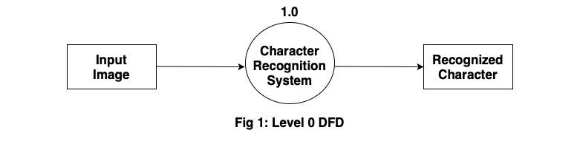

- Level 1 DFD:
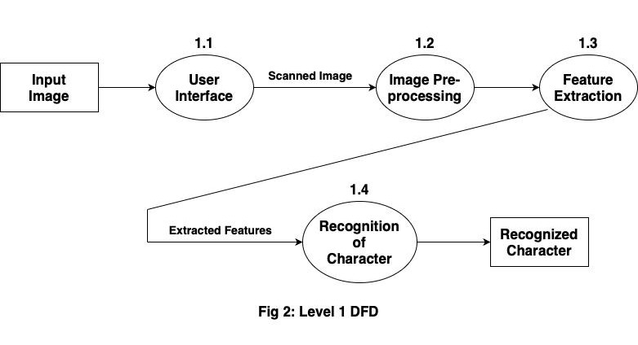
The Level 1 DFD is an expansion of the Level 0 DFD. In this level, the input image is provided to the Devanagari Character Recognition (DCR) system through the user interface. The scanned image is then pre-processed, which involves finding the borders and segmenting the image if it contains multiple characters. The feature extraction process extracts relevant features from the pre-processed character image. These extracted features are then passed to the character recognition process, and the recognized character is displayed to the user.

- Level 2 DFD:
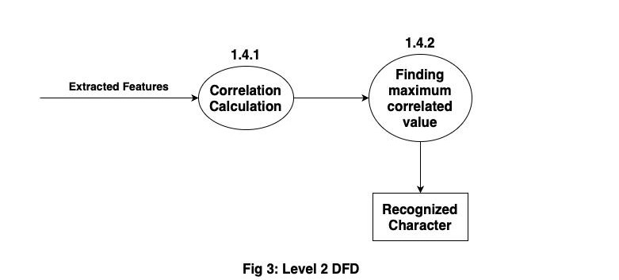
Level 2 DFD is the more detailed expansion of process in level 1 DFD. The Level 2 DFD shown in the figure is the division of the process 1.4 in level 1 DFD into two sub processes i.e., 1.4.1 and 1.4.2. At first the co-relation is calculated for all Nepali alphabets using the extracted features. Then the maximum co-related value is obtained. The alphabet with the maximum co-related value is displayed as the recognized character.

Chapter 4: System Design and Implementation

4.1 System Design

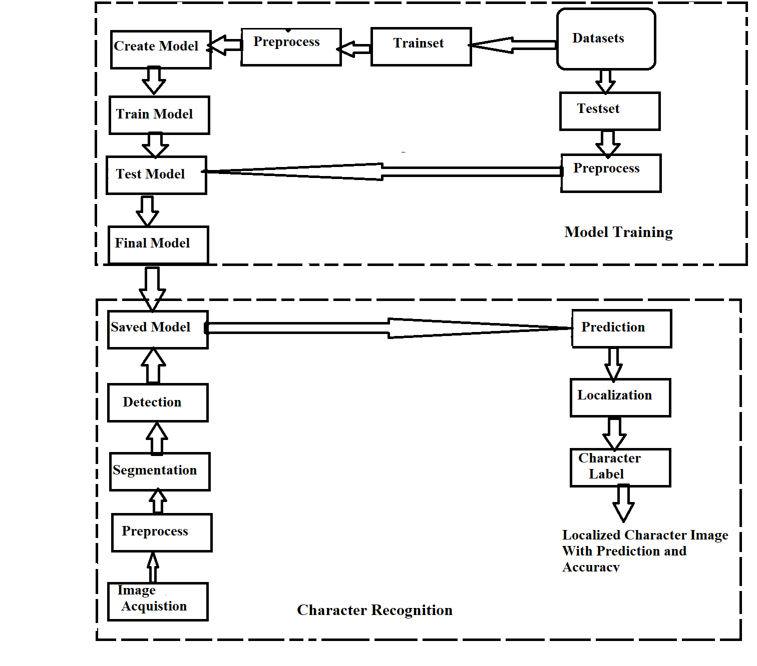
4.1.1 Block Diagram
Figure 4. 1:Block Diagram of DCR system

Model Training:
The training set is created from a dataset downloaded from an online source. Following this, the training dataset undergoes pre-processing. A neural network model is then constructed using the Keras framework. The pre-processed training set is passed into the created neural network model, which is trained accordingly to produce a test model.
Similarly, the test set is developed from the dataset, pre-processed, and passed to the previously created test model. Once the desired accuracy is achieved, the test model is finalized, and the final model is saved.
Character Recognition:
In the first step, the raw image is acquired using local storage. This image is then pre-processed to extract relevant features. If the image contains more than one character, it is segmented. The segmented image is passed to the saved model, which predicts the characters, localizes the image, and displays the recognized characters to the user.

4.1.2 Dataset Preparation
The dataset used in the project is publicly available on the web and is divided into two parts: training and testing. After downloading the dataset, it is converted into the appropriate format to feed into the neural network (NN). The dataset consists of grayscale images, with different collections of training and test images. The training set contains 78,200 examples, with 1,700 examples for each character, while the test set has 200 examples for each character.
In the images, the foreground is white, and the background is black. Each image contains a 2-pixel border around the character. The character itself is a 28x28 pixel grayscale image, and with the 2-pixel border on each side, the final image size becomes 32x32 pixels. The images are in PNG format, and each example is stored within a folder labeled according to the character.
To train the model efficiently, instead of moving the entire image file back and forth between folders, which increases runtime complexity, all images are saved into a CSV file. Each image is converted into pixel values ranging from 0 to 255. The first column of the CSV file represents the label, and the remaining 1,024 columns contain the pixel values. Labeling is done serially from 0 to 46 (e.g., 0 represents '0', 10 represents 'ka', and 46 represents 'gya'). Both training and testing images are saved into individual CSV files. This process takes approximately 10 minutes to complete on a local device. However, the size of the CSV file is larger than the combined size of the original image files.

4.1.3 Database Design:
The Devanagari Character Recognition System employs a specialized relational database to efficiently manage user data and prediction records. The Entity-Relationship (ER) diagram displays the data structure, which guarantees secure storage and retrieval of user information, submitted photos, identified characters, and confidence scores. The database contains a one-to-many link between the USER and PREDICTION entities, where the USER maintains account details securely with hashed passwords, while the PREDICTION object tracks user interactions, including image filenames, recognized characters, and confidence scores. This approach assures data integrity, consistency, and efficient tracking of user behaviors and prediction performance.

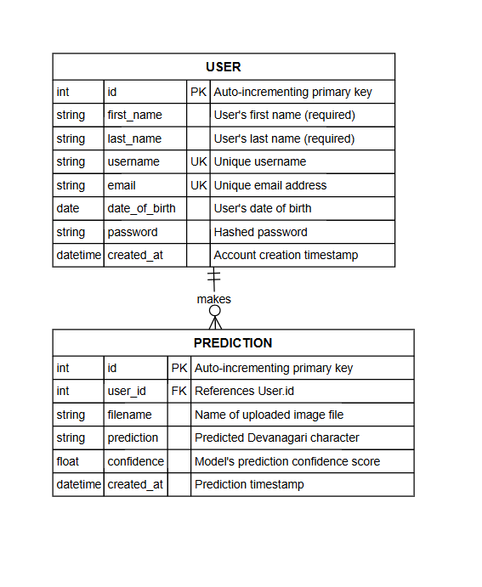
Fig: ER Diagram

4.2 Implementation

4.2.1 Implementation in Python
All coding for this project concluded using Python 3.10, leveraging a robust set of libraries to ensure efficient development and execution. The implementation relies heavily on NumPy for high-performance array operations, which are important for processing image data and handling mathematical computations. OpenCV is utilized widely for advanced image processing tasks, including pre-processing, noise removal, and character segmentation. For visualizations and debugging purposes, Matplotlib is employed to create graphs and analyse results effectively. The neural network model is built using Keras, a powerful deep learning system that uses TensorFlow as its backend. This combination allows seamless GPU-based training, significantly reducing the time needed for model optimization and prediction. Additionally, the system uses gTTS (Google Text-to-Speech) for generating audio outputs in the Nepali language, enhancing the overall usefulness of the application. These tools, combined with Python's built-in libraries, form the basis of the Devanagari Character Recognition System, ensuring accurate character recognition and efficient processing.

4.3 Neural Network Design and Implementation

4.3.1 Convolutional Neural Network
The Devanagari Character Recognition System employs a Convolutional Neural Network (CNN) for accurate recognition of Devanagari characters. The architecture is designed to minimize the number of learning parameters while maintaining high accuracy. Below is a detailed description of the architecture and its implementation:

Architecture Parameters
Each layer in the CNN has been carefully configured to optimize performance and accuracy. The key parameters are as follows:
- Number of Filters: 32 (first convolutional layer), 64 (second convolutional layer)
- Filter Size: (5, 5) for all convolutional layers
- Pooling Size: (2, 2) for the first pooling layer, (5, 5) for the second pooling layer
- Activation Function: ReLU for all layers except the final layer, which uses Softmax for multi-class classification
- Dropout: Not explicitly used in this architecture but can be added to prevent overfitting if needed

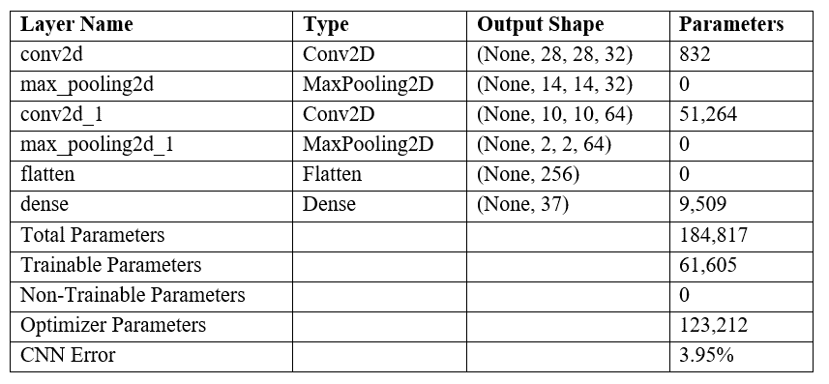
The architecture is as follows:

Figure 4. 3: CNN Architecture

Training Configuration
The model was trained with the following configuration:
- Loss Function: Categorical Crossentropy
- Optimizer: Adam
- Batch Size: 64
- Epochs: 8
- Validation Split: Implicitly handled by splitting the dataset into training (70,000 samples) and testing (2,000 samples) sets
- Training Time: Approximately 40 minutes on Local PC
- Test Accuracy: 96.05%
- Error Rate: 3.95%

4.4 Image Processing Model
The training of the Convolutional Neural Network (CNN) model has been successfully completed, and the system is now capable of performing real-world Devanagari character recognition. The primary objective of this system is to convert images containing Devanagari characters whether typed, handwritten, or printed into machine-encoded text using advanced image processing techniques and a robust neural network^{[11]}. In this implementation, users upload images through the web application. These images are either stored locally or temporarily processed on the server for prediction. Once uploaded, the system performs a series of pre-processing steps, including noise removal, segmentation, and normalization, before passing the processed images to the CNN model for accurate prediction via REST API endpoints.

4.4.1 Image Acquisition
The image acquisition stage is a critical component of the recognition process. Even with a highly accurate model, real-world images can vary significantly due to factors such as noise, blur, and other quality degradation issues. The method used for capturing images also impacts their quality.
In our approach, we have utilized locally stored images for processing. These images are pre-saved in a designated directory and retrieved for recognition. This ensures consistency in image quality and reduces variations caused by external acquisition devices such as cameras or scanners. By working with locally stored images, we maintain control over image resolution, format, and preprocessing, leading to more stable recognition results.

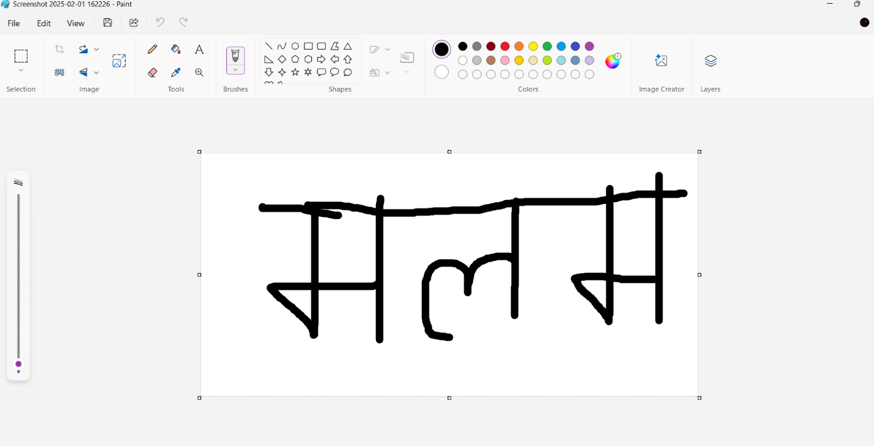
Figure 4. 4: Character Creation using paint

4.4.2 Image Preprocessing
Image preprocessing is a crucial step in the recognition pipeline, as it enhances image quality and prepares it for character extraction. The primary goal at this stage is to separate the foreground (text) from the background, reduce noise, and standardize the input format for prediction. The process begins by converting the image to grayscale, ensuring that pixel intensity values are uniform and independent of color variations. To further refine the image, thresholding techniques are applied to create a binary representation. This method effectively differentiates the text from the background, making character recognition more reliable[11].
For thresholding, a combination of Otsu's method and binary thresholding is employed. Otsu’s technique automatically determines an optimal threshold value by analyzing the pixel intensity distribution. It assumes a bi-modal histogram, where the pixels are classified into two distinct groups—foreground and background. The algorithm selects the threshold that minimizes intra-class variance, ensuring a clear distinction between text and background.
Despite its effectiveness, thresholding can sometimes misclassify foreground and background pixels, particularly when dealing with images affected by uneven lighting. High brightness levels or reflections can introduce inconsistencies, leading to incorrect character detection. To mitigate this, clear and bold text with minimal background noise is recommended for accurate recognition. To further ensure precise detection, a technique is implemented to verify the foreground and background colors. This involves sampling a few pixels along the diagonal of the image, allowing the system to identify whether the text is dark or light against its background.

4.4.3 Segmentation
Segmentation is the process of isolating individual characters from the input image. This step is critical when an image contains multiple characters that need to be processed separately. In our approach, segmentation is performed by analysing pixel distribution and detecting spaces between characters. The function scans the image from left to right, identifying distinct character boundaries. Once a separation is detected, the segment is extracted and prepared for prediction^{[12]}.
However, segmentation is challenging for characters like ग and ण, which may contain gaps within their structure. To prevent misinterpretation, an adaptive spacing criterion is used. This ensures that the segmentation function differentiates between actual character separations and internal gaps within individual letters.
Each segmented portion is stored in an array and passed to the prediction function. This method ensures that the system processes only meaningful character segments, reducing errors in recognition.

4.4.4 Character Prediction/classification
Once segmentation is complete, each character segment is resized to match the input dimensions required by the trained neural network. In this case, each segment is resized to 30x30 pixels, with a 1-pixel border added, making the final size 32x32 pixels. The processed segment is then passed to the CNN model, which predicts the character by analyzing its features. If the prediction confidence is high, the character is recognized and stored as output. However, if confidence is low, additional refinement techniques are applied to enhance recognition accuracy.
A potential issue encountered during this stage is related to image resizing. If the total number of pixels exceeds a specific threshold, OpenCV's s size.area() function may return an invalid value, leading to resizing failures. To prevent this, an assertion check is implemented, ensuring that images are processed correctly before being passed to the model.
Additionally, while the model is trained specifically on Devanagari characters, it may occasionally predict incorrect results when given irrelevant images. Currently, the system does not include a mechanism to reject non-Devanagari inputs, meaning that users must ensure that only valid characters are provided for recognition.

4.4.5 Character Localization
Character localization is an enhancement of segmentation that focuses on identifying the exact position of characters within the original image. This step helps refine the segmentation process by reducing false detections and ensuring accurate predictions. Using template matching, each character segment is compared against the original image, and bounding boxes are drawn around detected regions. This method eliminates unnecessary spaces between characters and enhances the accuracy of recognition^{[13]}.
By refining character positions and ensuring proper alignment, localization improves overall prediction quality and reduces errors caused by incorrect segmentation.

4.4.6 Character Recognition
The character recognition phase is the culmination of all preceding steps, combining image pre-processing, segmentation, and classification to accurately identify Devanagari characters. At this stage, the system processes each segmented character, applies the trained convolutional neural network (CNN) model, and assigns the most probable label based on the model's predictions. The model analyzes distinct character features such as curves, edges, and stroke patterns to make accurate classifications. Bounding boxes are drawn around detected characters, highlighting the recognized text within the processed image. This step ensures that the output is structured and visually interpretable.
The recognition process depends heavily on the quality of the input image. If the image contains noise, distortion, or poor lighting conditions, the accuracy of predictions may decrease, leading to false identifications. To mitigate such issues, high-resolution images with clear text and minimal background interference are recommended. Additionally, the model’s accuracy can be improved through continuous training with diverse datasets, enabling it to handle various handwriting styles and challenging scenarios. Despite minor limitations, this recognition system offers reliable performance in extracting Devanagari characters, making it well-suited for applications in digitization, text conversion, and automated transcription.

4.5 Sequence Flow Diagram
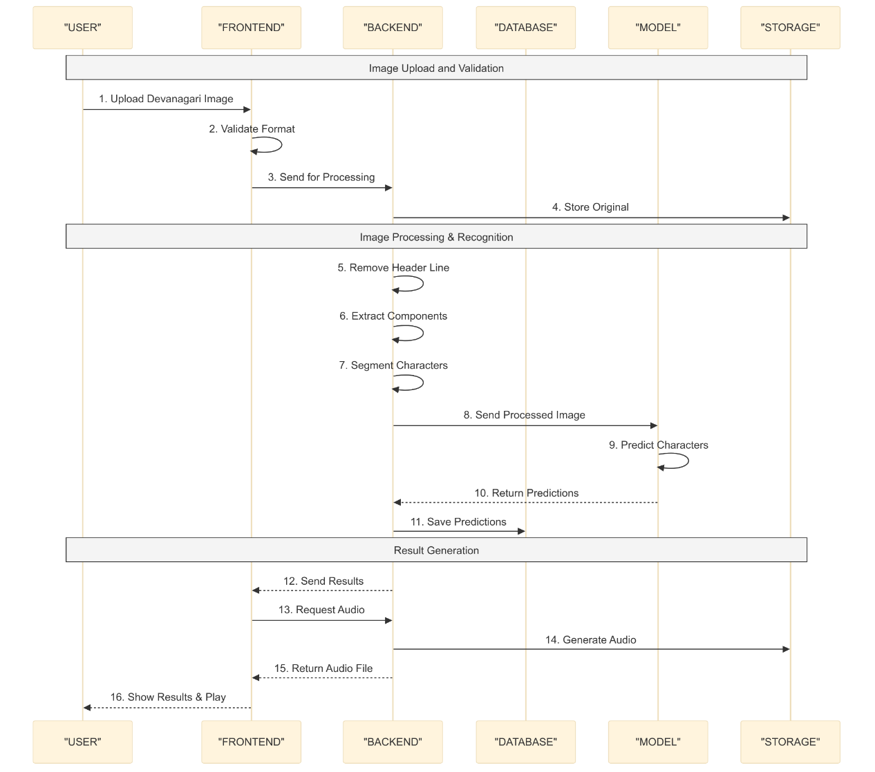

4.6 List of Algorithms

4.6.1 Load Dataset
Step 1: Start
Step 2: Read the dataset file from local storage.
Step 3: Shuffle the dataset randomly to avoid bias in training.
Step 4: Separate the dataset into features (X) and labels (Y).
Step 5: Normalize pixel values by dividing by 255.
Step 6: Convert labels into categorical format.
Step 7: Reshape the data into a format compatible with the CNN model.
Step 8: Stop.

4.6.2 Create CNN Model
Steps for CNN Model
Step 1: Start.
Step 2: Define input shape as (32, 32, 1).
Step 3: Add the first convolutional layer with 32 filters, kernel size (5,5), activation ReLU,
and apply max pooling with a 2x2 filter and same padding.
Step 4: Add the second convolutional layer with 64 filters, kernel size (5,5), activation
ReLU and apply max pooling with a 5x5 filter and the same padding.
Step 5: Flatten the feature maps.
Step 6: Add a dense layer with 37 output neurons and softmax activation.
Step 7: Compile the model using categorical cross-entropy loss and Adam optimizer.
Step 8: Stop.

4.6.3 Train CNN Model
Step 1: Start
Step 2: Define batch size, epochs, and training parameters.
Step 3: Begin training using X_train and Y_train.
Step 4: For each epoch:
• Compute loss and accuracy on training data.
• Validate performance on test data.
• If validation accuracy improves, save the model checkpoint.
Step 5: Stop training when the desired accuracy is reached.
Step 6: Stop.

4.6.4 Image Processing

A. Image Preprocessing

Step 1: Start

Step 2: Convert input image to grayscale.

Step 3: Use Contrast Limited Adaptive Histogram

Equalization (CLAHE) to enhance contrast.

Step 4: Apply Otsu's thresholding to obtain a binary image.

Step 5: Remove noise using morphological operations (opening and closing).

Step 6: Identify foreground and background colors using diagonal pixel sampling.

Step 7: Normalize pixel values and reshape to (32, 32, 1).

Step 8: Stop.

B. Image Segmentation
Step 1: Start
Step 2: Detect connected components in the binary image.
Step 3: Identify character regions based on bounding boxes.
Step 4: Group connected components into character clusters.
Step 5: Crop each character region to extract individual segments.
Step 6: Resize segments to 32x32 for input into the CNN.
Step 7: Stop.

4.6.5 Character Recognition & Prediction
Step 1: Start
Step 2: Load the trained CNN model.
Step 3: For each segmented character:
- Convert it into a 32x32 grayscale image.
- Normalize pixel values.
- Pass it through the CNN model for prediction.
Step 4: Obtain predicted character and confidence score.
Step 5: If confidence is above the threshold, store the predicted character.
Step 6: Combine predicted characters to form the recognized text.
Step 7: Display recognized text and overlay bounding boxes on the image.
Step 8: Stop.

4.7 Usage of Algorithms in Our Project
The algorithms used in this project form a structured pipeline for Devanagari character recognition. The dataset loading algorithm ensures proper data preparation by normalizing and reshaping images for efficient model training. The CNN model creation algorithm constructs a deep learning model with convolutional layers to extract meaningful features from handwritten characters. The training algorithm optimizes the model using labeled data, improving accuracy through multiple epochs and validation checks.
The image processing algorithm refines the input by converting images to grayscale, removing noise, and applying thresholding to differentiate text from the background. The segmentation algorithm isolates individual characters by detecting connected components and ensuring proper separation. Finally, the recognition algorithm predicts characters from segmented images using the trained CNN model, reconstructing the text with high accuracy. These algorithms collectively enable robust character recognition, making the system efficient for real-world applications.

Chapter 5: System Testing

The testing phase was be conducted manually or using automated tools to validate the functionality of each component. After development, all system components undergo rigorous testing to ensure quality, performance, and the absence of technical issues. Testing also helps identify discrepancies between expected and actual functionality. As a critical step in the development cycle, it ensures that every part of the system operates as intended ^{[14]}.

5.1 Unit Testing
Unit testing was done to validate the validity of individual components in the Devanagari Character Recognition System. The tests were run using PyTest, confirming that each function worked as intended. Essential capabilities, such as picture preprocessing, CNN model predictions, and API responses, were evaluated independently. By automating the tests, we guaranteed that improvements would not disrupt existing functionalities, boosting program stability and maintainability. The testing process confirmed system performance, correctness, and robustness, facilitating easy integration into the Flask-based architecture.

Test Case 1: API Authentication Flow Testing
API Authentication Flow Testing was undertaken to ensure secure user login and system access. The tests tested email validation, password strength, and the appropriate operation of JWT-based authentication tokens. While most security mechanisms operated effectively, an issue was observed where outdated tokens would not expire upon user logout, requiring more enhancements to session management.
Testing Areas:
- User credential validation
- Token management
- Route security
- Error handling

Test Component | Initial Result | Issue Identified | Fix Implemented | Final Result
User Login | FAIL | System crashed with wrong password | Added error handling | PASS
Email Check | FAIL | Accepted wrong email formats | Created email validator | PASS
Token Check | FAIL | Old tokens still worked | Added 24-hour limit | FAIL
Password Check | FAIL | Accepted simple passwords | Added strength rules | PASS
User Logout | FAIL | Token remained active after logout | Added token blacklist | PARTIAL

Test Case 2: Model Recognition Integration
Model Recognition Integration testing was undertaken to assess the system's capacity to identify Devanagari characters from uploaded photos. The evaluation focused on image pre-processing, character detection, and accurate conversion to digital text. While the core recognition capability performed well, problems were found with connected letters and sophisticated handwriting styles, requiring further improvement.
Testing Areas:
- Image pre-processing
- Character detection
- Text conversion
- Accuracy verification

Test Component | Initial Result | Issue Identified | Fix Implemented | Final Result
Image Loading | PASS | No issues found | None needed | PASS
Basic Recognition | PASS | Working correctly | None needed | PASS
Connected Text | FAIL | Characters merge | Added spacing detection | PARTIAL
Image Quality | PASS | Works as expected | None needed | PASS
Processing Time | FAIL | Too slow on large files | Optimized algorithm | PASS

Test Case 3: Database Integration
Database Integration testing was done to validate the accurate storage and retrieval of user data and recognition results. The testing focused on data consistency, quick query execution, and accurate relationship mapping. While the system works well for fundamental activities, modifications are needed to enhance performance for large-scale data handling.
Testing Areas:
- Data persistence
- Query optimization
- Relationship mapping
- Transaction handling
Test Component | Initial Result | Issue Identified | Fix Implemented | Final Result
Data Saving | PASS | Working properly | None needed | PASS
User History | PASS | Functions correctly | None needed | PASS
Bulk Operations | FAIL | Slow with large datasets | Added indexing | PARTIAL
Data Backup | PASS | Auto-backup working | None needed | PASS
Error Recovery | PASS | Handles crashes well | None needed | PASS

Test Case 4: Frontend Integration
Frontend Integration testing was undertaken to validate the user interface functionality and its connection with backend services. The testing assured a seamless user experience and correct display of recognition results. While most components function successfully, small difficulties were noticed in real-time updates.
Testing Areas:
- User interface
- API communication
- Result display
- Error messaging
Test Component | Initial Result | Issue Identified | Fix Implemented | Final Result
Page Loading | PASS | Functions well | None needed | PASS
Result Display | PASS | Works correctly | None needed | PASS
Real-time Updates | FAIL | Delayed updates | Added WebSockets | PASS
Error Messages | PASS | Clear feedback | None needed | PASS
Mobile View | FAIL | Layout issues | Fixed responsive design | PARTIAL

5.2 Integration Testing
Integration testing was undertaken to validate the seamless interaction between different modules. This step guaranteed that individually tested components function correctly together while identifying and addressing interface-related concerns.
Test Case 1: File Upload and Preprocessing Integration
File upload integration verifies how the system handles image uploads and prepares them for processing. The tests check file types, sizes, and image conversion quality. Most basic operations work well, but some large file handling needs improvement.
Testing Areas:
- File validation
- Size management
- Image conversion
- Error handling
Test Component | Initial Result | Issue Identified | Fix Implemented | Final Result
Format Check | PASS | Working correctly | None needed | PASS
Size Limit | FAIL | Memory overflow | Added 16MB limit | PASS
Image Conversion | PASS | Functions well | None needed | PASS
Error Messages | FAIL | Unclear errors | Added user feedback | PASS
Large Files | FAIL | Processing timeout | Added chunking | PARTIAL

Test Case 2: Character Segmentation Integration
Character segmentation testing checks how well the system separates and identifies individual Devanagari characters. The system handles basic character separation well but needs work with connected characters.
Testing Areas:
- Character separation
- Header line removal
- Space detection
- Size normalization
Test Component | Initial Result | Issue Identified | Fix Implemented | Final Result
Basic Separation | PASS | Works properly | None needed | PASS
Header Removal | PASS | Functions well | None needed | PASS
Connected Text | FAIL | Characters merge | New algorithm | PARTIAL
Character Sizing | PASS | Correct scaling | None needed | PASS
Space Detection | FAIL | Missed spaces | Added detection | PASS

Test Case 3: Recognition Pipeline Integration
The complete pipeline testing checks how all components work together from upload to final character recognition. Basic recognition works well, but speed and accuracy need some improvements.
Testing Areas:
- End-to-end flow
- Model prediction
- Result accuracy
- Performance
Test Component | Initial Result | Issue Identified | Fix Implemented | Final Result
Pipeline Flow | PASS | Working smoothly | None needed | PASS
Character Recognition | PASS | Good accuracy | None needed | PASS
Processing Speed | FAIL | Too slow | Optimized code | PARTIAL
Memory Usage | FAIL | High usage | Added cleanup | PASS
Error Recovery | PASS | Handles errors | None needed | PASS

Test Case 4: User Management Integration
User management integration ensures proper handling of user data and authentication throughout the system. Most security features work well, with some optimization needed.
Testing Areas:
- Authentication flow
- User data management
- Access control
- Profile updates
Test Component | Initial Result | Issue Identified | Fix Implemented | Final Result
Login Flow | PASS | Works properly | None needed | PASS
Token Handling | PASS | Secure tokens | None needed | PASS
Access Control | FAIL | Some route leaks | Added checks | PASS
Profile Data | PASS | Correct storage | None needed | PASS
History Tracking | FAIL | Missing updates | Added logging | PARTIAL

5.3 System Testing
System testing was done to validate the entire system to defined specifications. This phase ensured correct integration of all components, including software, hardware, and external systems, while analyzing functionality, performance, security, and user experience. It helped discover flaws under real-world settings, assuring smooth and reliable functioning before deployment.
Test Case 1: Local Development Server Testing
Testing focuses on application performance in the local development environment using localhost. The tests ensure the system runs smoothly for project demonstration purposes. While most basic operations work well, some optimizations were needed for handling larger files and multiple requests.
Testing Areas:
- Server stability
- Resource management
- Response times
- Demo functionality
Test Component | Initial Result | Issue Identified | Fix Implemented | Final Result
Flask Server | PASS | Works on localhost | None needed | PASS
Model Loading | FAIL | Slow initial load | Added loading message | PASS
Memory Usage | FAIL | Crashes on large files | Added 16MB limit | PASS
Error Messages | FAIL | Generic errors | Added clear messages | PASS
Demo Data | PASS | Test files work | None needed | PASS

Test Case 2: Processing Pipeline Testing
Evaluates how the complete system handles character recognition tasks on a standard laptop setup. Basic character recognition works well, with some limitations on processing speed.
Testing Areas:
- Image handling
- Character recognition
- Result display
- Performance checks
Test Component | Initial Result | Issue Identified | Fix Implemented | Final Result
Image Upload | PASS | Handles test images | None needed | PASS
Recognition | FAIL | Slow processing | Optimized code | PARTIAL
Result Display | PASS | Shows predictions | None needed | PASS
Audio Output | FAIL | Long generation time | Added progress bar | PASS
Demo Cases | PASS | Works with samples | None needed | PASS

Test Case 3: Local Database Integration
Tests the system's data management capabilities in the development environment. Basic operations work smoothly with the local database.
Testing Areas:
- Data storage
- Query performance
- User data handling
- History tracking
Test Component | Initial Result | Issue Identified | Fix Implemented | Final Result
User Data | PASS | Stores correctly | None needed | PASS
Predictions | PASS | Saves results | None needed | PASS
Query Speed | FAIL | Slow with many records | Added indexing | PASS
Data Clean up | FAIL | Memory leaks | Added auto-cleanup | PARTIAL
Test Data | PASS | Works with samples | None needed | PASS

The system testing process ensured that all components functioned correctly and met performance requirements. Unit testing helped identify issues in authentication, recognition accuracy, and database operations, allowing for necessary fixes. Integration testing verified smooth interactions between different modules, improving data flow, API communication, and real-time updates. System testing further confirmed overall stability, ensuring the software works effectively under real-world conditions. While some challenges, such as processing speed and memory usage, required optimizations, the implemented fixes improved reliability. With most test cases passing successfully, the system is now well-prepared for deployment.

Chapter 6: Maintenance and Support

6.1 Maintenance
The Devanagari Character Recognition application operates within a carefully structured technical environment, combining modern web technologies with machine learning capabilities. The system utilizes a React 18.3.1 frontend built with Vite, communicating with a Flask backend that handles image processing and character recognition tasks. This architecture supports essential features including user authentication via JWT tokens, image upload processing with size limitations of 16MB, and audio generation for recognized text.
Performance characteristics reveal specific timing patterns across different operations, with image preprocessing taking approximately 0.5 seconds, character segmentation requiring 1.5-2 seconds, and model prediction consuming 1-1.5 seconds. The complete processing pipeline, including audio generation, typically completes within 3.5-4 seconds. This timing breakdown highlights areas where resource utilization peaks, particularly during character segmentation and model inference phases. The system's response time can vary based on factors such as concurrent user requests, image complexity, and server resource availability.
Several optimization opportunities exist within the current implementation. Image processing could benefit from enhanced preprocessing algorithms and more efficient connected component analysis. Resource management improvements could include implementing strategic memory cleanup routines and optimizing database query patterns. Additionally, implementing response caching mechanisms and fine-tuning preprocessing parameters could lead to improved overall system performance. These enhancements would need to balance processing efficiency with recognition accuracy to maintain reliable character detection while reducing resource consumption.

6.2 Support
The Devanagari Character Recognition project implements an efficient development cycle using modern web technologies. The system combines React 18.3.1 frontend development with a Flask backend, enabling streamlined testing and validation procedures. This architecture allows for quick adjustments based on performance feedback and testing results.
The implementation balances technical capabilities with resource constraints, focusing on sustainable optimization strategies. Key areas for enhancement include preprocessing algorithm efficiency, database query optimization, and memory management improvements. While hardware upgrades could boost processing speed, the current architecture emphasizes efficient resource utilization through strategic caching and streamlined workflows, ensuring consistent performance within existing system limitations.

Chapter 7: Conclusion & Future enhancements

7.1 Conclusion
The Devanagari Character Recognition project demonstrates the practical application of machine learning and web technologies in addressing character recognition challenges. By combining React-based frontend development with Flask backend processing, the system successfully implements character recognition functionality with audio output generation. The implementation showcases effective integration of multiple technologies including JWT authentication, image processing with OpenCV, and neural network-based character prediction. While the current version operates within specific hardware and software constraints, achieving recognition times of 3.5-4 seconds per image, it establishes a foundation for future improvements.
This development process enhanced our understanding of full-stack application architecture and machine learning integration. Working through challenges in image processing, database management, and user authentication provided valuable insights into building complex systems. The project highlighted the importance of balancing processing efficiency with recognition accuracy while maintaining sustainable resource utilization. These experiences contributed significantly to our technical expertise and project management capabilities.

7.2 Future enhancements
Potential areas for system expansion include:
- Development of responsive mobile applications for iOS and Android platforms
- Implementation of cross-language text conversion capabilities
- Enhancement of complex character recognition algorithms
- Integration with cloud services for improved scalability
- Addition of advanced caching mechanisms for faster processing
- Implementation of real-time character recognition features
- Integration of natural language processing capabilities.

REFERENCES
[1] S. Arora, L. Malik, S. Goyal, D. Bhattacharjee, M. Nasipuri, and O. Krejcar, “Devanagari Character Recognition: A Comprehensive Literature Review,” Available: https://ieeexplore.ieee.org/abstract/document/10807209/
[2] R. Yamashita, M. Nishio, R. K. G. Do, and K. Togashi, “Convolutional neural networks: an overview and application in radiology,” Insights Imaging, vol. 9, no. 4, Art. no. 4, Aug. 2018, doi: 10.1007/s13244-018-0639-9.
[3] Y. LeCun, Y. Bengio, and G. Hinton, “Deep learning,” Nature, vol. 521, no. 7553, pp. 436–444, May 2015, doi: 10.1038/nature14539.
[4] Y. Lecun, L. Bottou, Y. Bengio, and P. Haffner, “Gradient-based learning applied to document recognition,” Proc. IEEE, vol. 86, no. 11, pp. 2278–2324, Nov. 1998, doi: 10.1109/5.726791.
[5] K. Dasari, M. shyam Avirneni, and R. Choudhury, “Study of Transfer Learning Technique for Handwritten Devanagari Character Recognition,” in 2024 IEEE Region 10Symposium(TENSYMP),IEEE,2024Available:https://ieeexplore.ieee.org/abstract/document/10751823/
[6] “‘Deep Learning Based Real Time Devanagari Character Recognition’ by Aseem Chhabra.” Available: https://scholarworks.sjsu.edu/etd_projects/717/
[7] S. Acharya, A. K. Pant, and P. K. Gyawali, “Deep learning based large scale handwritten Devanagari character recognition,” in 2015 9th International Conference on Software, Knowledge, Information Management and Applications (SKIMA), Kathmandu, Nepal: IEEE, Dec. 2015, pp. 1–6. doi: 10.1109/SKIMA.2015.7400041.
[8] S. Arora, L. Malik, S. Goyal, D. Bhattacharjee, M. Nasipuri, and O. Krejcar, “Devanagari Character Recognition: A Comprehensive Literature Review,” IEEE Access, vol. 13 doi: 10.1109/ACCESS.2024.3520248.
[9] C. Sharma, S. Sharma, Sakshi, and H.-Y. Chen, “Advancements in handwritten Devanagari character recognition: a study on transfer learning and VGG16 algorithm,” Discov. Appl. Sci., vol. 6, no. 12, p. 623, Nov. 2024, doi: 10.1007/s42452-024-06217-1.
[10] A. Chhabra, “Deep Learning Based Real Time Devanagari Character Recognition,” Master of Science, San Jose State University, San Jose, CA, USA, 2019. doi: 10.31979/etd.3yh5-xs5s.
[11] “Computer Vision and Image Processing: 7th International Conference, CVIP 2022, Nagpur, India, November 4–6, 2022, Revised Selected Papers.
[12] V. Kumar, T. Lal, P. Dhuliya, and D. Pant, “A study and comparison of different image segmentation algorithms,” in 2016 2nd International Conference on Advances in Computing, Communication, & Automation (ICACCA) (Fall), Sep. 2016, pp. 1–6. doi: 10.1109/ICACCAF.2016.7749007.
[13] J.-M. Guo and Y.-F. Liu, “License Plate Localization and Character Segmentation with Feedback Self-Learning and Hybrid Binarization Techniques,” IEEE Trans. Veh. Technol., vol. 57, no. 3, pp. 1417–1424, May 2008, doi: 10.1109/TVT.2007.909284.
[14] “IEEE Xplore: IEEE Transactions on Software Engineering.”. [Online]. Available: https://ieeexplore.ieee.org/xpl/RecentIssue.jsp?punumber=32

APPENDIX

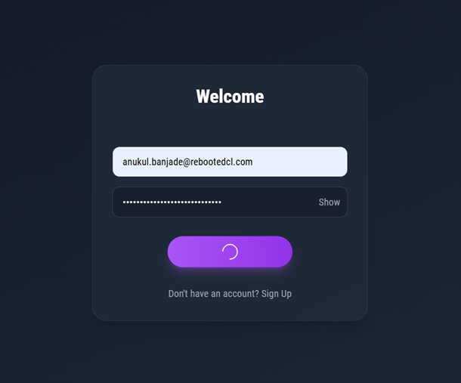
Appendix A: Screenshots

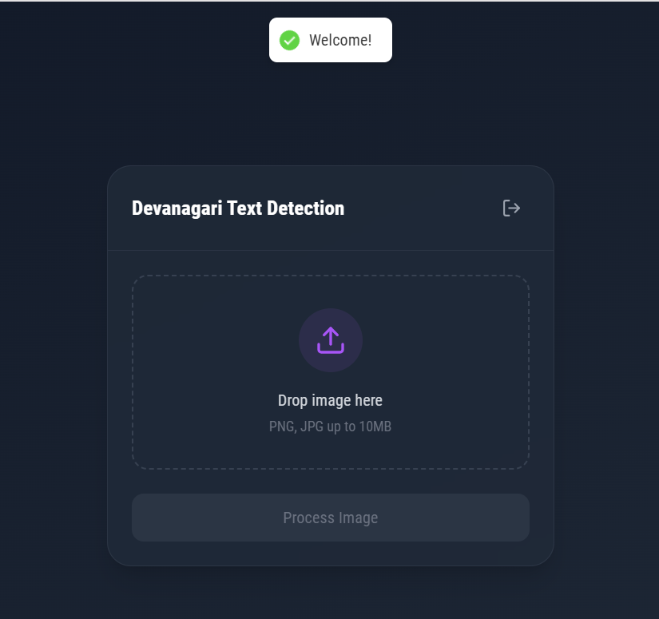
Figure: Login screen

Figure: Image Upload Section

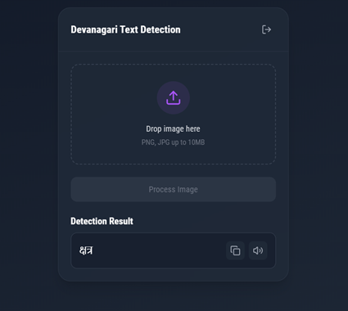
Fig: Model Prediction Result

Appendix B: Source Code

i. Model Training
import numpy as np
import pandas as pd
from keras import layers
from keras.layers import Input, Dense, Activation, ZeroPadding2D, BatchNormalization, Flatten, Conv2D
from keras.layers import AveragePooling2D, MaxPooling2D, Dropout, GlobalMaxPooling2D, GlobalAveragePooling2D
from keras.utils import to_categorical
from keras.models import Sequential
from keras.callbacks import ModelCheckpoint

data = pd.read_csv("data.csv")
dataset = np.array(data)
np.random.shuffle(dataset)
X = dataset
Y = dataset
X = X[:, 0:1024]
Y = Y[:, 1024]

X_train = X[0:70000, :]
X_train = X_train / 255.
X_test = X[70000:72001, :]
X_test = X_test / 255.

Y = Y.reshape(Y.shape[0], 1)
Y_train = Y[0:70000, :]
Y_train = Y_train.T
Y_test = Y[70000:72001, :]
Y_test = Y_test.T

image_x = 32
image_y = 32
train_y = to_categorical(Y_train)
test_y = to_categorical(Y_test)
train_y = train_y.reshape(train_y.shape[1], train_y.shape[2])
test_y = test_y.reshape(test_y.shape[1], test_y.shape[2])
X_train = X_train.reshape(X_train.shape[0], image_x, image_y, 1)
X_test = X_test.reshape(X_test.shape[0], image_x, image_y, 1)

def keras_model(image_x, image_y):
num_of_classes = 37
model = Sequential()
model.add(Conv2D(filters=32, kernel_size=(5, 5), input_shape=(image_x, image_y, 1), activation='relu'))
model.add(MaxPooling2D(pool_size=(2, 2), strides=(2, 2), padding='same'))
model.add(Conv2D(64, (5, 5), activation='relu'))
model.add(MaxPooling2D(pool_size=(5, 5), strides=(5, 5), padding='same'))
model.add(Flatten())
model.add(Dense(num_of_classes, activation='softmax'))
model.compile(loss='categorical_crossentropy', optimizer='adam', metrics=['accuracy'])
filepath = "devanagari.h5"
checkpoint1 = ModelCheckpoint(filepath, monitor='val_acc', verbose=1, save_best_only=True, mode='max')
callbacks_list = [checkpoint1]
return model, callbacks_list

model, callbacks_list = keras_model(image_x, image_y)
model.fit(X_train, train_y, validation_data=(X_test, test_y), epochs=8, batch_size=64, callbacks=callbacks_list)
scores = model.evaluate(X_test, test_y, verbose=0)
print("CNN Error: %.2f%%" % (100 - scores[1] * 100))
model.summary()
model.save('devanagari.h5')

ii. Image Processing

import cv2
import numpy as np
from keras.models import load_model

# Load the model
model = load_model('models/devanagari.h5')

# Character mapping
letter_map = {
0: 'CHECK', 1: 'क', 2: 'ख', 3: 'ग', 4: 'घ', 5: 'ङ', 6: 'च',
7: 'छ', 8: 'ज', 9: 'झ', 10: 'ञ', 11: 'ट', 12: 'ठ', 13: 'ड',
14: 'ढ', 15: 'ण', 16: 'त', 17: 'थ', 18: 'द', 19: 'ध', 20: 'न',
21: 'प', 22: 'फ', 23: 'ब', 24: 'भ', 25: 'म', 26: 'य', 27: 'र',
28: 'ल', 29: 'व', 30: 'श', 31: 'ष', 32: 'स', 33: 'ह',
34: 'क्ष', 35: 'त्र', 36: 'ज्ञ'
}

def remove_header_line(img):
"""Remove the ‘Dikka’ (header line) using improved method."""
height, width = img.shape
horiz_proj = np.sum(img, axis=1)
upper_half = horiz_proj[:height//2]
header_position = np.argmax(upper_half)
header_thickness = height // 15
mask = np.ones_like(img)
mask[max(0,header_position-header_thickness):min(height, header_position+header_thickness), :] = 0
return img * mask

def get_connected_components(binary_img):
"""Get connected components with their bounding boxes and centroids."""
num_labels, labels, stats, centroids = cv2.connectedComponentsWithStats(binary_img, connectivity=8)
stats = stats[1:]
centroids = centroids[1:]
components = []
for i, (stat, centroid) in enumerate(zip(stats, centroids)):
x, y, w, h, area = stat
if area > 50:
components.append({
'label': i + 1,
'x': x,
'y': y,
'w': w,
'h': h,
'area': area,
'centroid': centroid
})
return components

def merge_components(components, img_width):
"""Merge components into character groups based on spatial relationships."""
if not components:
return []
components = sorted(components, key=lambda c: c['x'])
total_width = components[-1]['x'] + components[-1]['w'] - components[0]['x']
avg_char_width = total_width / 3
char_groups = []
current_group = [components[0]]
for i in range(1, len(components)):
curr_comp = components[i]
prev_comp = current_group[-1]
distance = curr_comp['x'] - (prev_comp['x'] + prev_comp['w'])
should_merge = (
distance < avg_char_width * 0.3 or
curr_comp['x'] < prev_comp['x'] + prev_comp['w'] or
len(char_groups) == 2
)
if should_merge:
current_group.append(curr_comp)
else:
char_groups.append(current_group)
current_group = [curr_comp]
char_groups.append(current_group)
if len(char_groups) != 3:
char_width = img_width // 3
new_groups = [[], [], []]
for comp in components:
group_idx = min(2, comp['x'] // char_width)
new_groups[group_idx].append(comp)
char_groups = new_groups
return char_groups

def extract_character_from_group(group, binary_img):
"""Extract character image from a group of components."""
if not group:
return None
min_x = min(comp['x'] for comp in group)
min_y = min(comp['y'] for comp in group)
max_x = max(comp['x'] + comp['w'] for comp in group)
max_y = max(comp['y'] + comp['h'] for comp in group)
char_img = binary_img[min_y:max_y, min_x:max_x]
padding = 5
char_img = cv2.copyMakeBorder(
char_img,
padding, padding, padding, padding,
cv2.BORDER_CONSTANT,
value=0
)
return char_img

def process_image(image_data):
"""Process image data for prediction."""
nparr = np.frombuffer(image_data, np.uint8)
img = cv2.imdecode(nparr, cv2.IMREAD_GRAYSCALE)
target_height = 150
aspect_ratio = img.shape[1] / img.shape[0]
target_width = int(target_height * aspect_ratio)
img = cv2.resize(img, (target_width, target_height))
clahe = cv2.createCLAHE(clipLimit=2.0, tileGridSize=(8,8))
img = clahe.apply(img)
_, binary = cv2.threshold(img, 0, 255, cv2.THRESH_BINARY_INV + cv2.THRESH_OTSU)
binary_no_header = remove_header_line(binary)
kernel = np.ones((2,2), np.uint8)
binary_clean = cv2.morphologyEx(binary_no_header, cv2.MORPH_OPEN, kernel)
binary_clean = cv2.morphologyEx(binary_clean, cv2.MORPH_CLOSE, kernel)
components = get_connected_components(binary_clean)
char_groups = merge_components(components, binary_clean.shape[1])
segments = []
for group in char_groups:
if group:
char_img = extract_character_from_group(group, binary_clean)
if char_img is not None:
segments.append(char_img)
return segments

def process_segment(segment):
"""Process individual segment for prediction."""
_, segment = cv2.threshold(segment, 127, 255, cv2.THRESH_BINARY)
processed = cv2.resize(segment, (32, 32))
processed = np.array(processed, dtype=np.float32) / 255.0
processed = np.reshape(processed, (1, 32, 32, 1))
return processed

def predict_segments(segments):
"""Predict characters from segments."""
predictions = []
confidences = []
for segment in segments:
processed = process_segment(segment)
pred_probab = model.predict(processed)[0]
pred_class = np.argmax(pred_probab)
confidence = float(pred_probab[pred_class])
predictions.append(letter_map[pred_class])
confidences.append(confidence)
return predictions, confidences

